Admin module:

Users: When we search by name, no updates or results appear, but if we search by role, the system provides the details effectively.

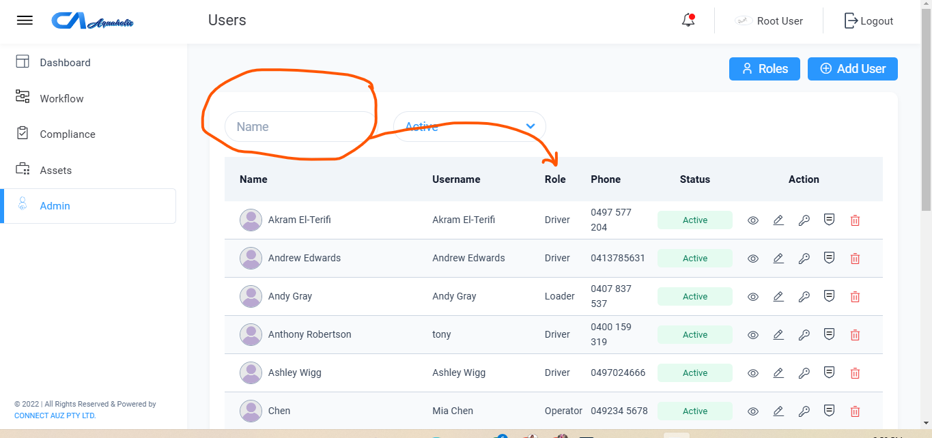

2.Workflow : Jobs:

1)When we select the ‘from date’ then also add the “to date “button. Also when add the from date previous to date automatic deleted.

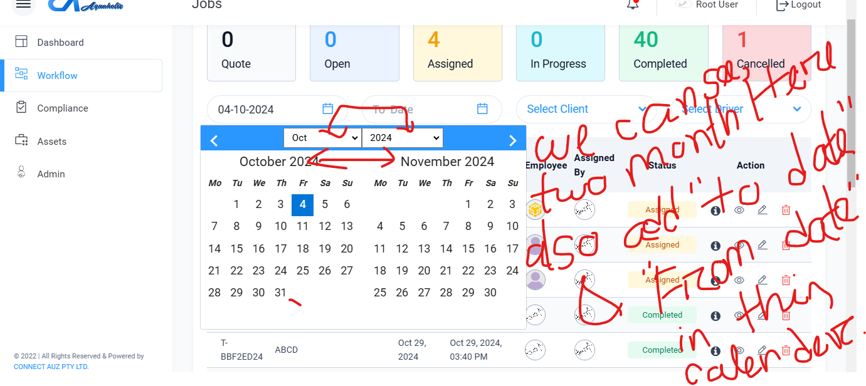

2)jobs: when  we want to search by date range It failed to show the exact result

33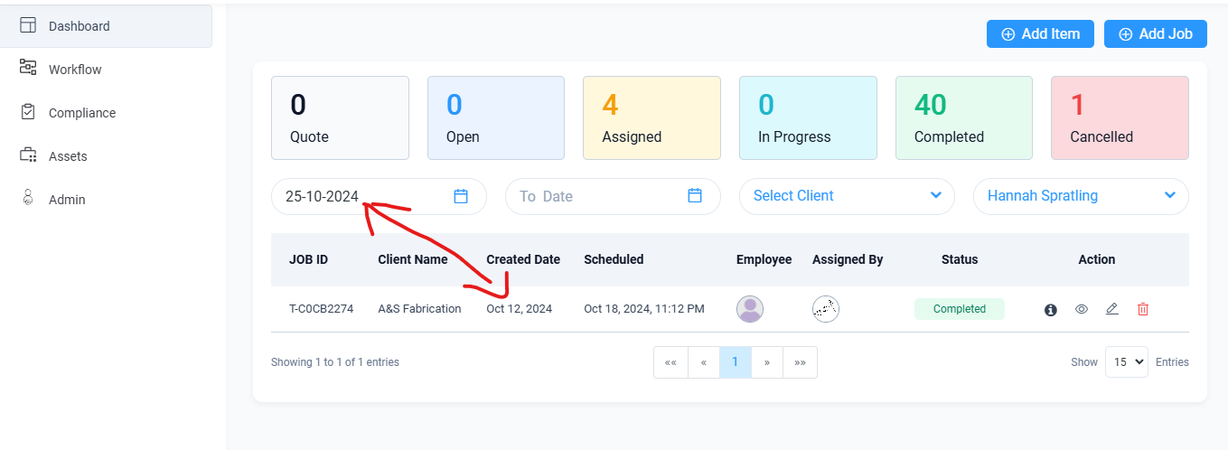

3. In the **Admin Module: Template -> Email Notification Section**, emails are being sent for **Post Check, Site Check,** and **Damage Check**. However, in our system, the **Compliance Module** only has the **Pre Check** component.

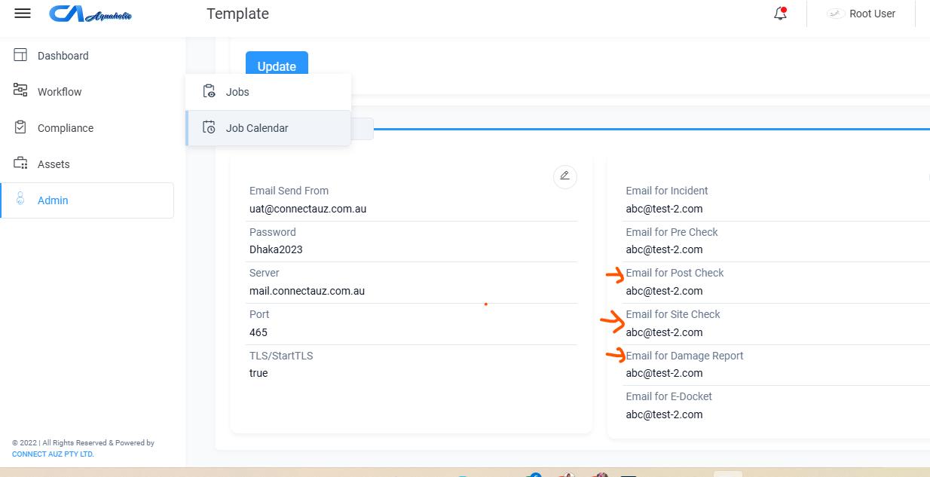

4) The system does not have an **Employee Module**, but the **Admin Module's Report Component** contains employee details.